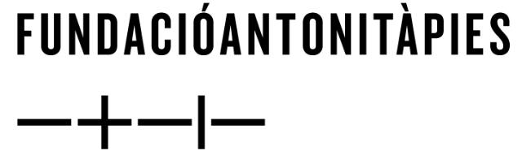
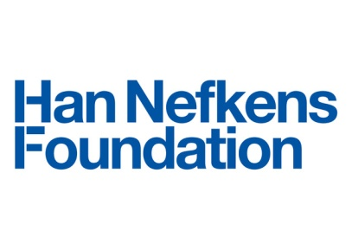

Giving Voices: Erkan Özgen invites reflection beyond the boundaries of politics to the intimate experiences of war

From November 13, 2018, to February 24, 2019.

Press conference and preview: November 16, at 12 pm.
Opening: November 16, at 7 pm.
Loop Festival press moment (tour and cocktail) RSVP: 20 November at 9:30 pm

Fundació Antoni Tàpies: Carrer d'Aragó, 255, 08007 Barcelona

- Giving Voices: Erkan Özgen is on view at the Fundació Antoni Tàpies in Barcelona from 13 November 2018 to 24 February 2019
- As part of Loop Barcelona, the The Han Nefkens Foundation and the Fundació Antoni Tàpies present Erkan Özgen’s the artist’s first solo exhibition in Spain
- The winner of the the Han Nefkens Foundation - LOOP Video Art Award 2018 will be announced during the Loop Festival (20 to 22 November)

Barcelona, 5 October 2018: The Han Nefkens Foundation and the Fundació Antoni Tàpies are delighted to announce the opening of Giving Voices: Erkan Özgen, the first solo exhibition of work by artist Erkan Özgen, from Turkey, to take place in Spain.

Curated by Hilde Teerlinck, Director of the Han Nefkens Foundation, the exhibition open on 13 November 2018 and forms part of the 16th edition of the video art festival, LOOP Barcelona.

With four videos, two of which were conceived especially for the exhibition in Barcelona, Erkan Özgen reveals the human cost of political turmoil, responding intelligently and respectfully to issues that are relevant, not only because they are ongoing, but also because they are global.

Özgen’s work invites a reflection beyond the boundaries of political issues, returning to the purely private and very human dimension of forgotten stories of violence, trauma and power. His work gives voice to a series of stories that could, due to rapid information flows, be erased or even intentionally overshadowed. These stories, which are often told with different levels of accuracy and objectivity, tackle the enormous challenges of relating the experiences of individuals.

The exhibition includes Purple Muslin (2018), a video by Özgen that premiered at the biennial Manifesta 12, held this year in Palermo, Italy, and was produced with the support of a Han Nefkens Foundation Production Grant. Currently still on view at Manifesta 12, it was selected for the ‘Out Of Control Room’ section. Created in collaboration with women refugees in Europe and Turkey who fled the war zones of northern Iraq, Özgen’s project explores the impact of the conflict on their lives.

Giving Voices’ also features Özgen's recent participation at the 15th Istanbul Biennial with the work Wonderland (2016), a video introducing a thirteen-year-old boy made deaf by bombardments. It explores the ineffability of acoustic trauma and argues for the importance of representing the inexpressible. Wonderland opens spaces for imagination, offering once more a gentle reminder of just how much we need peace.

Two new videos from Özgen, Memory of Times and Aesthetic of Weapons, will also premiere at Loop Festival. Both address humanity’s complex relationship with weapons, from very private and public perspectives, questioning the cultural value and heritage of arms.

The illustrated exhibition catalogue features a conversation between Erkan Özgen and Hilde Teerlinck, as well as contributions from Serpentine Galleries artistic director, curator and critic, Hans Ulrich Obrist; psychologist, psychotherapist and trauma expert, Dr. Jan Ilhan Kizilhan; Hong-Kong-based Turkish curator, Özge Ersoy, and anthropologist Rik Adriaan.

During the festival, the Han Nefkens Foundation will also announce the winner of the the Han Nefkens Foundation - LOOP Video Art Award 2018. The winning artist will receive $15,000 for the production of a new work and will donate one copy to the Han Nefkens Foundation, which will be included in its collection. The new work will be presented at the Fundació Joan Miró in Barcelona, coinciding with LOOP Festival 2019.

___

Erkan Özgen (Derik, Turkey, 1971)
Born to a Kurdish family in 1971, Erkan Özgen lives and works in Diyarbakır. Özgen made his debut into the Turkish art world in 1998 and since then has participated in exhibitions and events in Albania, Austria, Croatia, Cyprus, Estonia, France, Finland, Germany, Iran, Italy, Israel, Lebanon, Montenegro, Holland, Slovenia, Spain, Sweden, Switzerland, Turkey, Austria, the United Kingdom and the United States. Özgen primarily works with video, photography and installation. Most of his recent films address migration and human rights, often criticizing overcharged nationalism and military absolutism.

Han Nefkens Foundation
The Han Nefkens Foundation is a private, non-profit organization set up in Barcelona in 2009. It focuses on video, with the aim of connecting people through art across the world, collaborating with renowned international art institutions. The Foundation’s founding values have defined it from the beginning as an innovative and forward-thinking model: a production hub that oversees and promotes contemporary creation from the very first moments until the final presentation. Positioned as a platform for artists to advance in their careers, its main activity, always at the international level, is to commission works through its awards and grants.

Current projects at Han Nefkens Foundation

Production Awards:
Han Nefkens Foundation - ARCO Video Art Award (Madrid)
Han Nefkens Foundation - LOOP Art Fair Video Art Award (Barcelona)
Han Nefkens Foundation - CAC Award Latin-American Video Art (Quito)
Han Nefkens Foundation - BUK Museum Korean Video Art Award (Seoul)

Production Grants - Exhibitions:
Bundeskunsthalle, Bonn: Vaijko Chachkhiani
Manifesta 12, Palermo: Erkan Özgen
Gwangji Biennial: Heecheon Kim
Antòni Tapies Foundation: Erkan Özgen

______

Press Contact:

Enrichetta Cardinale Ciccotti at Pickles PR
Email: enrichetta@picklespr.com | Tel: +34 656 956672

